Nandhu Krishnan Muralidharan Nair

5140- U

November 7, 2023

individual project

developing insights using Toronto open data portal

**Introduction**

The Fire Incident Dashboard report and the COVID-19 Dashboard report provide valuable insights into two separate but equally important facets of public safety. The Fire Incident Dashboard offers a complete analysis of firefighting incidents, highlighting the criticality of rescue operations, the value of fire safety and prevention, and the necessity for efficient firefighting techniques and safety protocols. The COVID-19 Dashboard report elucidates the disparities in confirmed cases based on gender, the distribution of infections across different age groups, the sources of infection, and the significance of comprehensive data collecting. Furthermore, it emphasizes the necessity for additional research on COVID-19-associated deaths and provides valuable perspectives on the progression of the pandemic.

The findings collectively emphasize the crucial significance of utilizing data-driven decision-making to protect human lives and property. The data offered in these reports is an important resource for improving safety measures, mitigating the effects of disasters, and safeguarding the health and well-being of communities, whether in the context of fire events or public health crises. The implementation of fire safety and prevention measures plays a pivotal role in reducing economic losses and preserving human lives. Similarly, a comprehensive comprehension of COVID-19 data is necessary for the efficient administration and control of the virus.

**The Fire Incident Dashboard report**

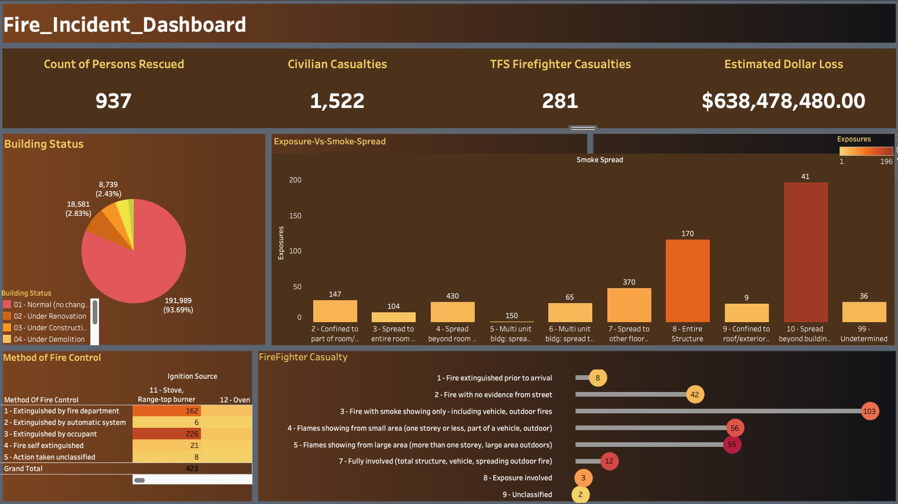

The Fire Incident Dashboard report provides a complete overview of essential statistics and data elements. The rescue of 937 individuals serves to emphasize the crucial significance of rescue operations within the context of firefighting incidents. The categorisation of buildings into different statuses, such as "Normal" (8,739 cases) and "Under Renovation" (18,581 cases), serves to highlight the potential occurrence of fires in diverse types of structures. This underscores the significance of implementing fire safety protocols both during the construction phase and in everyday situations. Regrettably, the occurrence of 1,522 civilian casualties serves to underscore the significant impact of fire occurrences on human lives, hence highlighting the imperative for the implementation of fire prevention measures, educational initiatives, and effective evacuation protocols. The data about exposure vs smoke spread is utilized to classify various levels of exposure, hence facilitating the formulation of focused firefighting tactics. The occurrence of 281 firefighter casualties serves as a poignant reminder of the valour and hazards encountered by first responders, underscoring the imperative for ongoing training initiatives and the implementation of robust safety regulations. The dataset about ignition sources provides valuable insights into the prevalent factors contributing to fires, promoting a heightened understanding of fire risks within residential and occupational settings. The substantial financial impact of fire events is shown by the anticipated dollar loss of $638,478,480.00. This underscores the significance of fire prevention, safety measures, and insurance in mitigating economic losses. This research offers significant insights that can educate decision-making, enhance safety measures, and develop strategies aimed at mitigating the impact of fires on both human lives and property. The importance of fire safety and prevention cannot be overstated, as it plays a crucial role in protecting human lives and mitigating the financial impact of fire-related events.

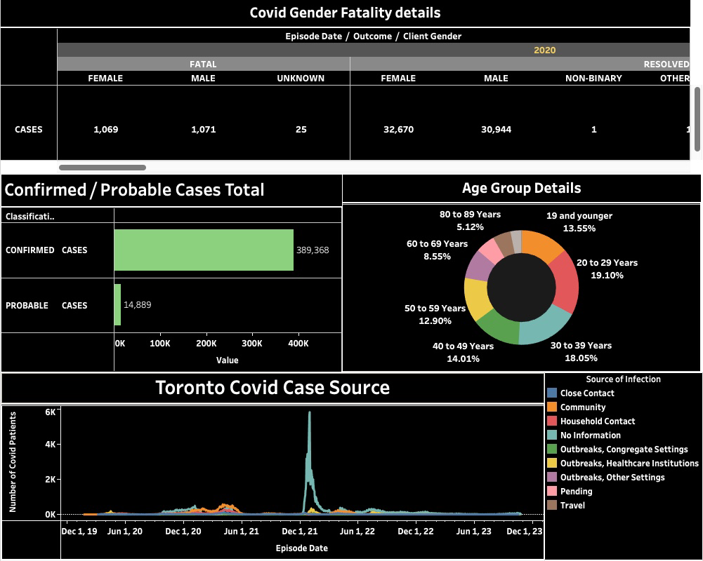**This COVID-19 dashboard report**

This COVID-19 dashboard report provides many insights that can be derived. To begin with, it is important to acknowledge a significant gender difference in the confirmed instances, wherein the number of cases among females (32,670) is considerably higher than that among males (1,069) and non-binary individuals (1,071). This observation implies the existence of possible disparities in the impact of diagnostic approaches for COVID-19 among different genders. The distribution of cases across different age groups exhibits a wide range, with the greatest proportion of cases observed among those aged 20 to 29 years (19.10%). It is noteworthy to mention that there exists a significant proportion of instances among individuals in younger age brackets, specifically 13.55% in the age group of 19 and below. This underscores the significance of closely monitoring and managing cases within younger demographics. The data moreover presents insights into the origins of infection, encompassing close contact, community transmission, and home contact. Furthermore, it is worth noting that there exist certain cases where information is not readily accessible, hence suggesting the presence of potential lacunae in data gathering. A comprehensive comprehension of the origins of infection is necessary to facilitate efficient contact tracing and disease management. Moreover, a total of 25 fatalities were documented, emphasizing the imperative for additional inquiry into the contextual elements surrounding these instances to comprehend the variables that contribute to fatality associated with COVID-19. The statistics provided by the "Toronto Covid Case Source" presumably pertain to the estimated range of COVID-19 cases (varying from 100,000 to 400,000) within the Toronto area. These values serve to provide valuable insights into the trajectory of the pandemic within the region. The insights above offer an initial comprehension of the COVID-19 issue, drawing upon the available data. However, a more exhaustive and practical study may necessitate further examination of contextual factors and a review of new data.

**Summary**

In conclusion, the Fire Incident Dashboard report and the COVID-19 Dashboard report demonstrate the need for data-driven methods for public safety and well-being. These papers underline the need to prevent and respond to fires and pandemics.

The Fire Incident Dashboard report stresses quick rescues, strict fire safety rules, and first responder training. It emphasizes the importance of data in understanding fire threats and minimizing financial damages. The COVID-19 Dashboard report highlights gender and age group differences in confirmed cases and the importance of monitoring infection origins for contact tracing. This highlights the need for rigorous investigations on COVID-19-related deaths to provide valuable pandemic insights.

In both cases, these studies help decision-makers enhance safety standards, save lives, and reduce the economic impact of catastrophic incidents. A robust and responsive society relies on preventive measures and data-driven policies. This research will continue to guide our public health and safety efforts.